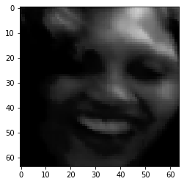

Happy 0.9998934268951416

[6.193649369379273e-06, 2.8710957849398255e-05, 0.9998934268951416, 5.836048148921691e-05, 1.3192645383242052e-05]

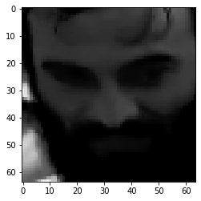

Angry 0.5235035419464111

[0.5235035419464111, 0.048544298857450485, 0.28297051787376404, 0.11016467213630676, 0.03481689468026161]

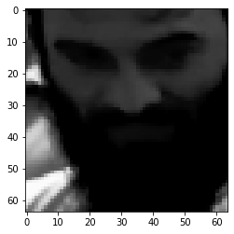

Neutral 0.4245198369026184

[0.3157300651073456, 0.09228461235761642, 0.056753676384687424, 0.4245198369026184, 0.11071176081895828]

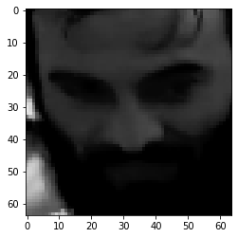

Angry 0.3891531229019165

[0.3891531229019165, 0.06545527279376984, 0.32333678007125854, 0.16080836951732635, 0.06124643236398697]

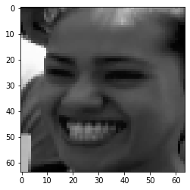

Happy 0.9997149109840393

[2.156417212972883e-05, 5.598348070634529e-05, 0.9997149109840393, 0.00019247434101998806, 1.4965098671382293e-05]

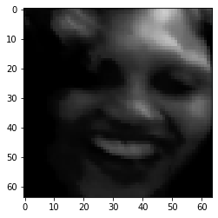

Happy 0.9999152421951294

[4.406866082717897e-06, 1.9663713828776963e-05, 0.9999152421951294, 5.049950777902268e-05, 1.0168142580369022e-05]

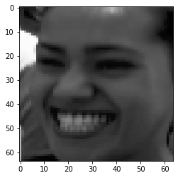

Happy 0.9999094009399414

[6.211855634319363e-06, 3.5496494092512876e-05, 0.9999094009399414, 4.454662121133879e-05, 4.3316886149114e-06]



Happy 0.9999094009399414

[6.211855634319363e-06, 3.5496494092512876e-05, 0.9999094009399414, 4.454662121133879e-05, 4.3316886149114e-06]